Order Management System
(Java Training)

Name-Ayush Singh
Enroll no-ADT23SOCB1589

1. Overview
A RESTful web application built with Spring Boot that manages the full lifecycle of customers, products, and orders. The system implements layered architecture, JPA entity relationships, and custom query methods, serving as a practical demonstration of enterprise backend development patterns.

2. Technologies

Technology | Purpose
Java 21 | Core programming language
Spring Boot 3 | Application framework & embedded Tomcat
Spring Data JPA | Repository abstraction and query derivation
Hibernate | ORM engine — entity ↔ table mapping
H2 Database | In-memory relational database
Lombok | Boilerplate elimination (@Data, @Getter, @Setter)
Maven | Build tool and dependency management
Postman | REST API testing and verification

3. Architecture
Standard three-layer Spring MVC structure:
Layer | Classes | Responsibility
Controller | CustomerController, OrderController, ProductController | Route HTTP requests
Service | CustomerService, OrderService, ProductService | Business logic
Repository | CustomerRepository, OrderRepository, ProductRepository | Data access via JPA
Entity | Customer, Product, Orders | Database-mapped objects
DTO | CustomerDto | Data transfer / projection

4. Entity Design
Customer (table: SwiggyCustomers)

Field | Type | Constraint
customerId | Long | PK · Auto-generated
name | String | NOT NULL
email | String | UNIQUE
city | String | —
age | int | —
bankUserName | String | —
password | int | —

Product (table: product)

Field | Type | Constraint
productId | Long | PK · Auto-generated
productName | String | —
price | double | —
category | String | —
quantity | int | —

Orders (table: Orders)

Field | Type | Notes
orderId | Long | PK · Auto-generated
quantityOrdered | int | —
totalPrice | double | price × qty (computed in service)
customer | Customer | FK → SwiggyCustomers (@ManyToOne)
product | Product | FK → product (@ManyToOne)

Relationship

Customer  (1) | One-to-Many  @ManyToOne | Orders  (Many)
Many-to-One
@ManyToOne
Product
(1)

5. API Endpoints
Customer /customers

Method | Endpoint | Description
GET | /customers | Get all customers
GET | /customers/{id} | Get customer by ID
GET | /customers/email/{email} | Get by email
GET | /customers/city/{city} | Get by city
GET | /customers/age/{age} | Get where age > value
POST | /customers | Create customer
POST | /customers/list | Bulk create customers
PUT | /customers/{id} | Update customer
DELETE | /customers/{id} | Delete customer

Product /products

Method | Endpoint | Description
GET | /products | Get all products
GET | /products/{id} | Get product by ID
GET | /products/category/{cat} | Get by category
POST | /products | Add product
POST | /products/list | Bulk add products
PUT | /products/{id} | Update product
DELETE | /products/{id} | Delete product

Orders /orders

Method | Endpoint | Description
GET | /orders | Get all orders
POST | /orders/{custId}/{prodId}/{qty} | Place order · total = price × qty

6. API Testing — Postman Screenshots
All endpoints tested via Postman at http://localhost:8082. Responses verified 200 OK with correct JSON structure.

GET /Customers :
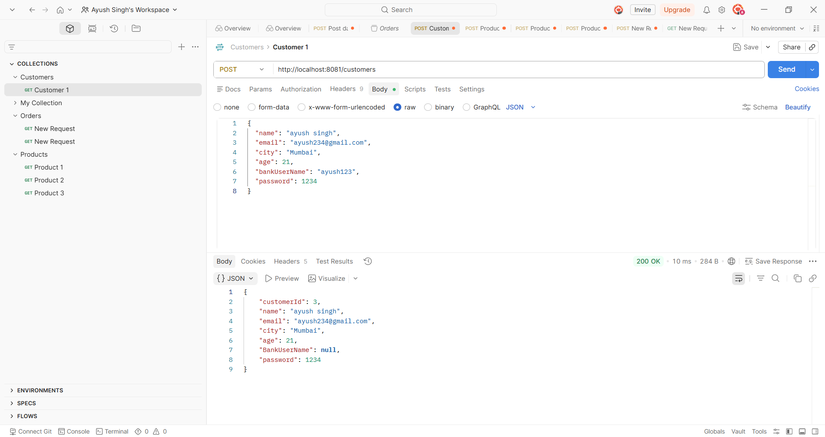

Get/Product:
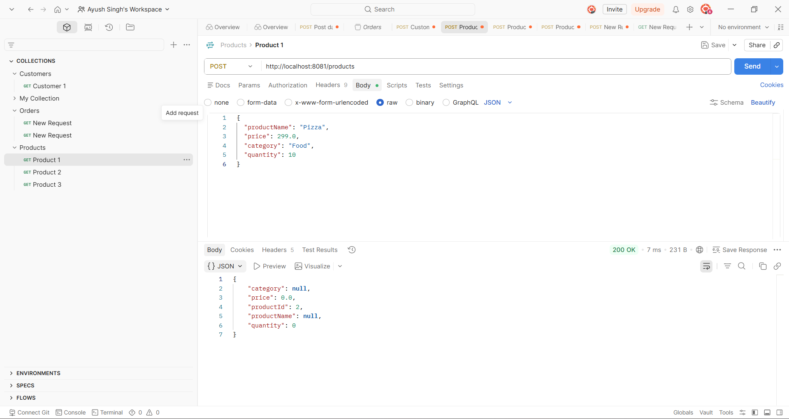

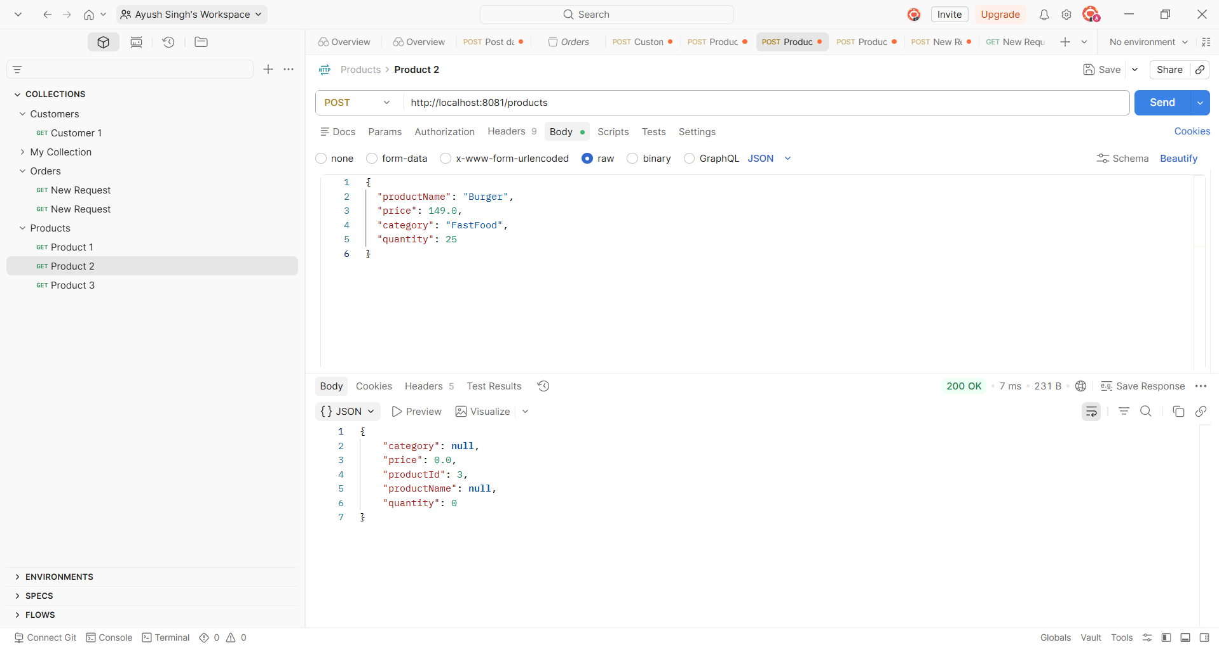

Get/ORDER:

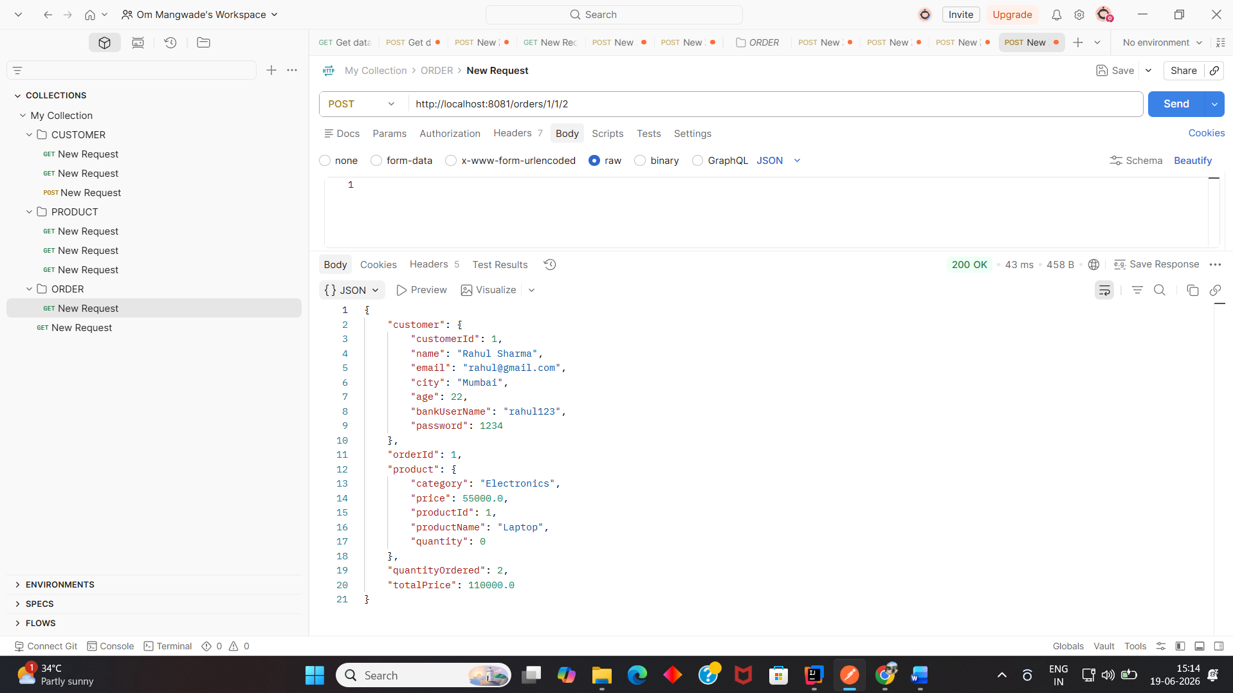

OUTPUT: Customer
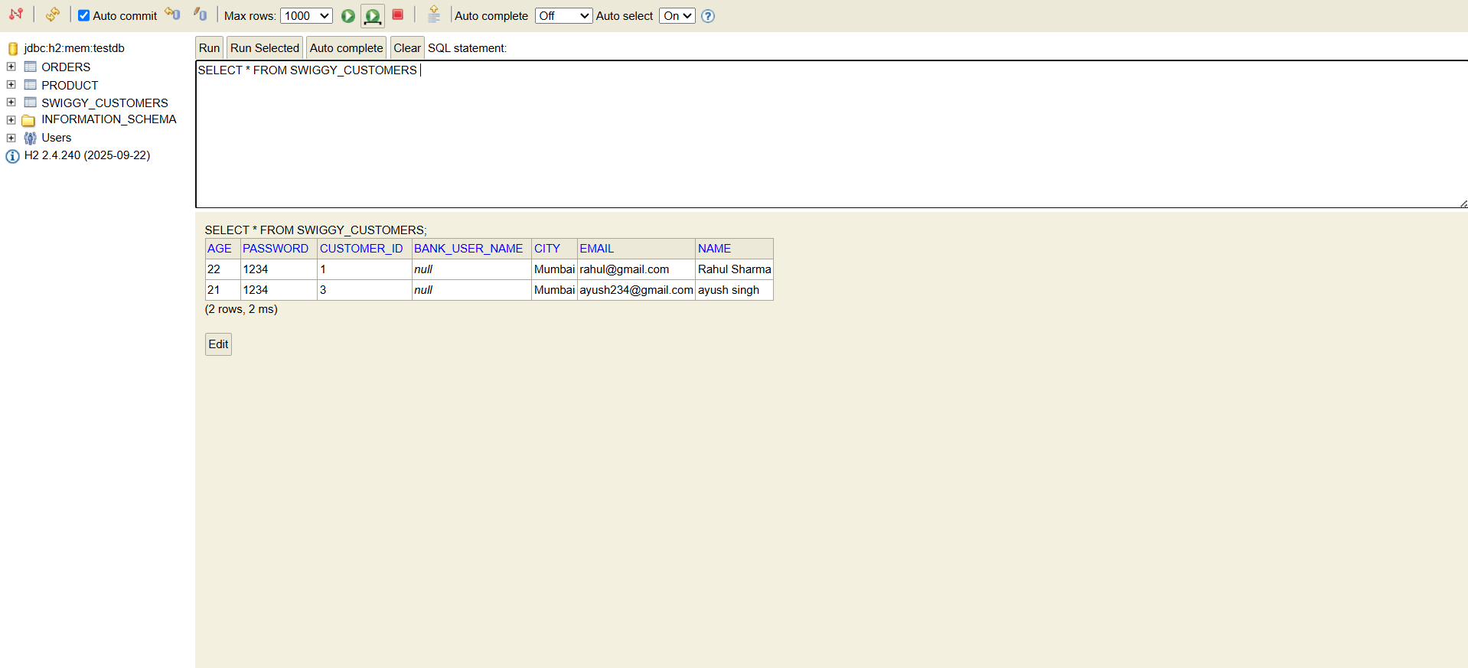
Output:Product
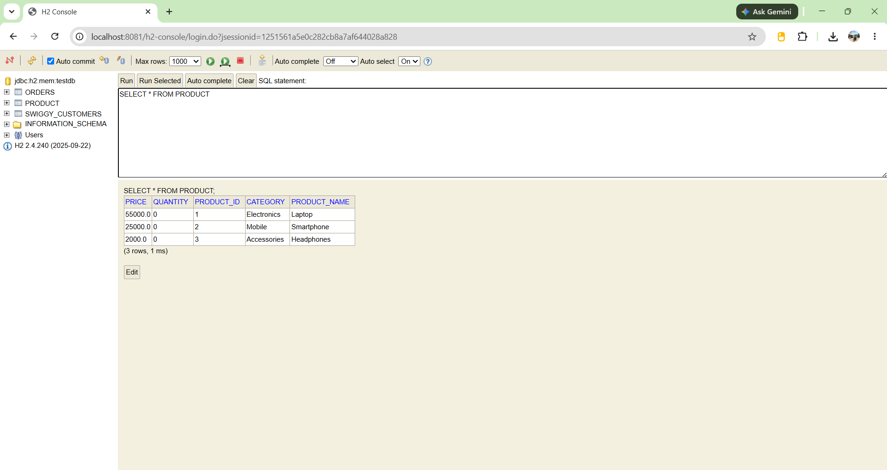

Output:Orders
